Summer Research Fellowship Programme, 2025

Developing an FPGA-Driven RRAM Crossbar Controller for Efficient In-Memory Computing

Prantik Basu, ENG51689,
IIT ISM DHANBAD
Guide: Prof. Sandip Mondal
IIT BOMBAY

ABSTRACT
In-memory computing has emerged as a promising alternative to overcome the data transfer bottlenecks in von Neumann architectures, especially for AI workloads [16]. Among non-volatile memories, Resistive Random Access Memory (RRAM) offers low power, high density, and analog programmability, making it a leading candidate for neuromorphic computing [1], [4]. In this work, we present a hardware prototype of an RRAM-based crossbar controller interfaced with an analog front-end and an FPGA-based digital backend. The system is capable of executing read/write operations on an 8×8 RRAM array using partial-bias voltage schemes and control logic implemented in Verilog. Simulations and experimental results confirm multilevel conductance switching, supporting matrix-vector multiplication (MVM) in memory—an essential operation for AI acceleration [6], [10]. This design emulates the function of a conventional memory controller while offering neuromorphic capabilities, and sets the stage for future implementation of spiking neural networks and in-memory learning systems.

ACKNOWLEDGEMENT
I express my sincere gratitude to the Indian Academy of Sciences (IAS) for providing me the opportunity to participate in the Summer Research Fellowship Programme (SRFP). I am deeply thankful to my guide, Prof. Sandip Mondal of IIT Bombay, for his constant support, technical guidance, and invaluable mentorship throughout the project. I also extend my heartfelt thanks to Prof. Nirupama Mondol, whose recommendation and encouragement played a crucial role in enabling my participation in this program.

CONTENTS
1. Introduction .................................................................................................................... 5
1.1 Motivation .......................................................................................................... 5
1.2 Background and Problem Statement ................................................................... 5
1.3 Objective of the Project ....................................................................................... 5
1.4 Report Structure ................................................................................................. 6
2. Literature Review ......................................................................................................... 7
2.1 Resistive RAM (RRAM) as an Emerging Non-Volatile Memory Technology ...... 7
2.2 Neuromorphic and In-Memory Computing Paradigms ....................................... 8
2.3 RRAM-Based Crossbar Arrays for AI Applications ............................................. 10
2.4 AI Accelerator Architectures Using RRAM ....................................................... 12
3. Proposed System Architecture ................................................................................. 14
3.1 Overall System Design ...................................................................................... 14
3.2 Analog Front-End Design .................................................................................. 15
3.3 Digital Backend Using FPGA ............................................................................ 16
3.4 Control Logic Implementation in Verilog ......................................................... 16
4. Simulation and Experimental Setup .......................................................................... 18
4.1 Simulation Environment ………………............................................................ 18
4.2 Experimental Setup ………………................................................................... 20
4.4 Result and Observations ...................................................................... 19
5. Conclusion and Future Scope .................................................................................. 22
6.1 Summary of Contributions ................................................................................ 23
6.2 Key Results and Design Achievements .............................................................. 23
6.3 Limitations and Challenges ................................................................................ 22
6.4 Future Work and Expansion Possibilities .......................................................... 22
6. References ..................................................................................................................... 23

CHAPTER 1
Introduction
1.1 Motivation
The explosive growth of data and the increasing complexity of machine learning and artificial intelligence (AI) workloads have intensified the demand for faster, energy-efficient computing systems. Traditional computing models, based on the von Neumann architecture, are increasingly inadequate for these applications due to the bottleneck created by the separation of memory and processing units. This limitation, often referred to as the “memory wall,” results in frequent data transfers, higher latency, and greater energy consumption [16].
To address this, new computing paradigms such as in-memory computing and neuromorphic computing have emerged. These approaches aim to reduce energy and latency overhead by co-locating memory and computation within the same physical hardware [17], [18]. One of the most promising enablers of these paradigms is Resistive Random Access Memory (RRAM) — a type of non-volatile memory that supports analog storage and low-power operation.
1.2 Background and Problem Statement
RRAM is particularly attractive due to its simple structure, fast switching speed, low voltage operation, and the ability to hold multiple resistance states per cell [1], [4]. These features make RRAM suitable not only for memory applications but also for computational primitives, especially matrix-vector multiplication (MVM), which is central to neural networks. When organized into crossbar arrays, RRAM devices can naturally perform parallel MVM operations by exploiting Ohm’s and Kirchhoff’s laws. This makes RRAM crossbars an ideal hardware substrate for implementing neuromorphic computing and AI accelerators [6], [10].
Despite its potential, the practical use of RRAM in real-world systems poses significant design challenges — especially regarding control logic, voltage biasing schemes, and circuit interfacing. These challenges are not just theoretical; building a complete system capable of robust read/write operations requires the careful coordination of analog front-end circuits and digital control units.
1.3 Objective of the Project
This project focuses on designing, simulating, and implementing a working controller for an RRAM-based 8×8 crossbar array. The controller:
- Integrates an analog front-end PCB to apply programmable voltages for read/write access.
- Uses an FPGA-based digital backend (coded in Verilog) to generate timing signals, control address decoding, and manage read/write sequences.
- Supports partial-bias voltage schemes to minimize sneak currents.
- Demonstrates synaptic behaviour, including multilevel resistance states and weight updates, thereby emulating core neuromorphic principles.
- Ultimately, the prototype aims to bring together memory functionality with computational behaviour on a single platform, paving the way for in-memory learning systems.
1.4 Report Structure
This report is organized into the following chapters:
- Chapter 2: Literature Review — Covers relevant research on RRAM devices, neuromorphic architectures, in-memory computing principles, and existing AI hardware accelerators.
- Chapter 3: System Architecture — Describes the overall design, including the analog front-end circuitry and FPGA-based control system.
- Chapter 4: Control Logic Design — Details the Verilog implementation of read/write protocols and signal generation logic.
- Chapter 5: Simulation and Signal Analysis — Discusses the simulation environment (e.g., LTSpice) and presents waveform analysis for both read and write operations.
- Chapter 6: Experimental Results — Provides details of the hardware implementation, setup, and measured performance of the controller.
- Chapter 7: Conclusion and Future Work — Summarizes the contributions of this project and outlines potential improvements, such as MAC integration and spiking neural network support.

CHAPTER 2
Literature Review
2.1 Resistive RAM (RRAM) as an Emerging Non-Volatile Memory Technology
All existing charge store-based non-volatile memory when scaled down to nano scale due to decrease in storage of charge are facing problems like degradation in performance, reliability, and noise margin [1]. And the most prominent of charge-based memory device Flash memory also faces challenges in low operating speed, limited endurance and High write voltage [2]. That’s why a new class of memory came up that depends upon the change of resistance rather than charge for storing data, Which are as follows:
- PCM (phase change memory) that relies in the difference in the resistance between crystalline and amorphous phase
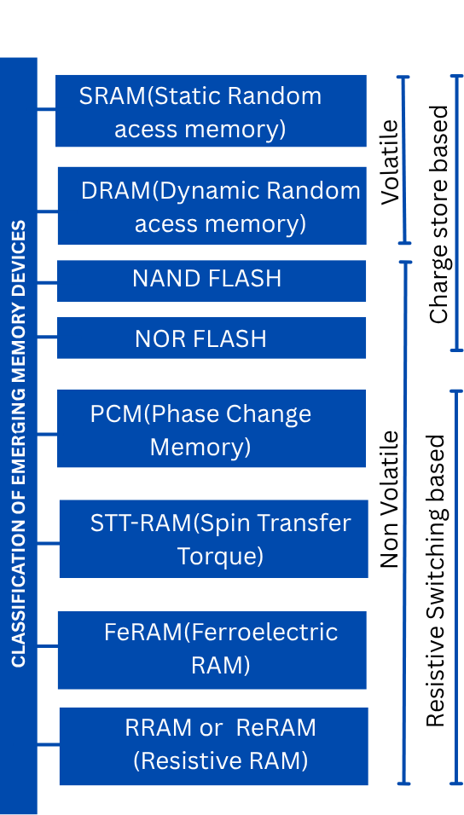
- STT-RAM (spin transfer torque) relies on magnetic tunnelling injection effect
- FeRAM (ferroelectric RAM) relies on magnetic tunnelling injection effect.
- RRAM (Resistive RAM) relies on the formation and rupture of conductive filament for filamentary type and electro-chemical metallization for non-filamentary type.

Fig 2.1.1: Classification of emerging memories

In comparison to all other memory technology RRAM gives High speed, Extreme scalability, long endurance, Low Power Consumption, multibit storage, simple structure and CMOS compatibility making it very widely used means of storage and also for neuromorphic applications [1]. It has been observed that in some insulators the change in resistance occurs when application of electric field [3]. By using the principal RRAM have been designed which is a Metal-Oxide Insulator sandwiched between two electrodes. Initially these RRAM is in High resistance state (HRS) and to switch the device from the HRS to LRS, the application of a write voltage pulse is applied enables formation of conductive filaments that decreases the resistance and if the reverse pulse is applied the LRS is again turn back into HRS state [4]. There are two types of RRAM which are CBRAM where the resistive switching mechanism is based on migration of metal ions and subsequent reduction and oxidation reaction and similarly OXRAM where the filament formation is based on generation of oxygen vacancies and subsequent relocation of oxygen ions thus enabling the formation of conductive filament.
2.2 Neuromorphic and In-Memory Computing Paradigms with RRAM.
As the need for computing power and requirement of memory storage is increasing day by day the existed state of art architectures like Von-Neuman Architecture, Haward Architectures where the memory and CPU are physically separated are facing large memory wall due to continuous communication between the CPU and memory [5]. That why there is a need of new computing paradigms. So, several brain-inspired paradigms have been explored such as Neuromorphic computing and In-memory Computing. Neuromorphic computing seeks to replicate brain’s functions by utilizing spiking neurons and synapses [18]. Synapse is the junction between two neurone and artificial neurone is the building block of neuromorphic computing hardware Fig 2.2.1. Neuromorphic computing can is a general word referring to both neural hardware and neural architectures like Spiking neural networks, they are based on a local learning rule know as Hebbian Learning and the mechanism is STDP (Spike time dependent plasticity) which is based on LTD and LTP [19].
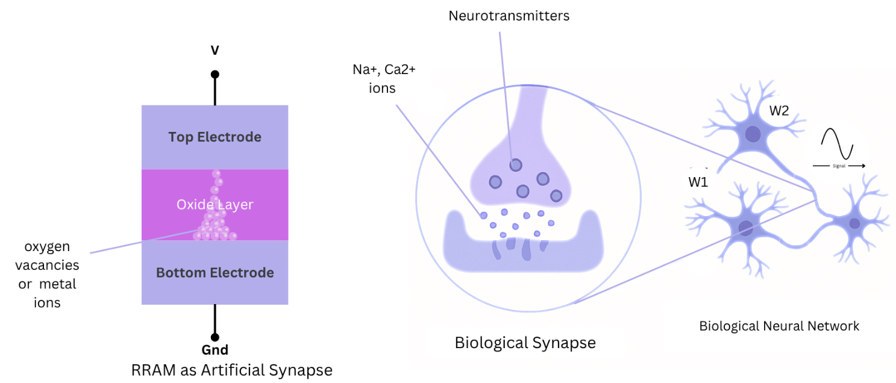

Fig 2.2.1: Comparison with Biological Synapse and RRAM

RRAM shows certain phenomena that leads to synaptic behaviour. The most important feature is nonvolatility, multilevel-conductance state and STDP. RRAM shows multilevel conductance state due to formation of partial filaments, when a pulse is applied of certain voltage the filament starts forming and conductance start increasing and as number of pulses increases the conductance increases more Fig: 2.2.2. These same phenomena can also be used to justify LTP (long term potentiation) and LTD (long term depression) which means increasing and decreasing synaptic strength (conductance for RRAM) with application of spikes or action potentials (voltage pulse for RRAM) these LTP and LTD is the basis of memory of brain and any neuromorphic device. Some other properties such as Gradual and bidirectional conductance change, Low operation power, stochasticity and fast switching speed are shown by RRAM. So, RRAM has been widely recognized as a potential artificial synapse.
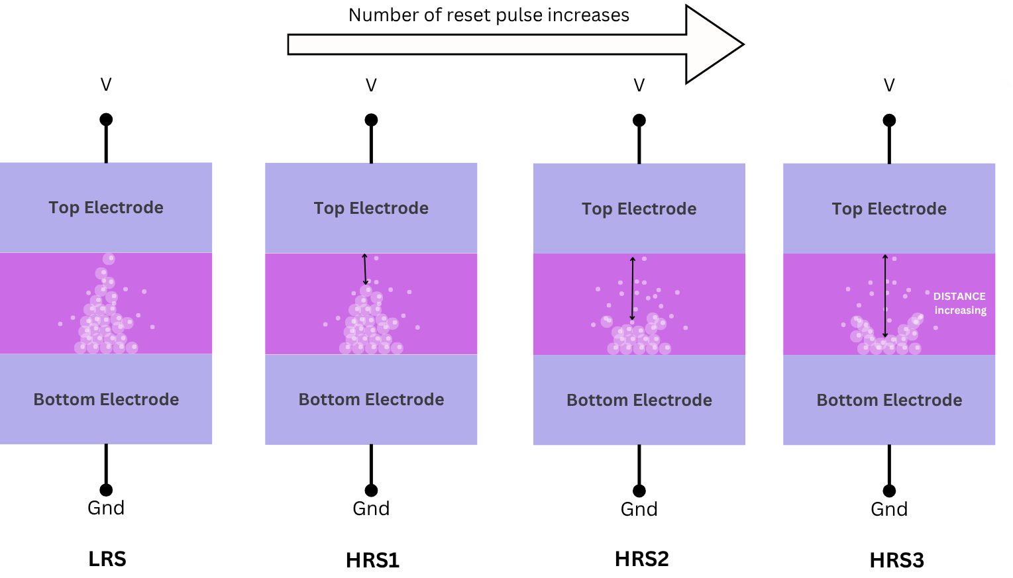
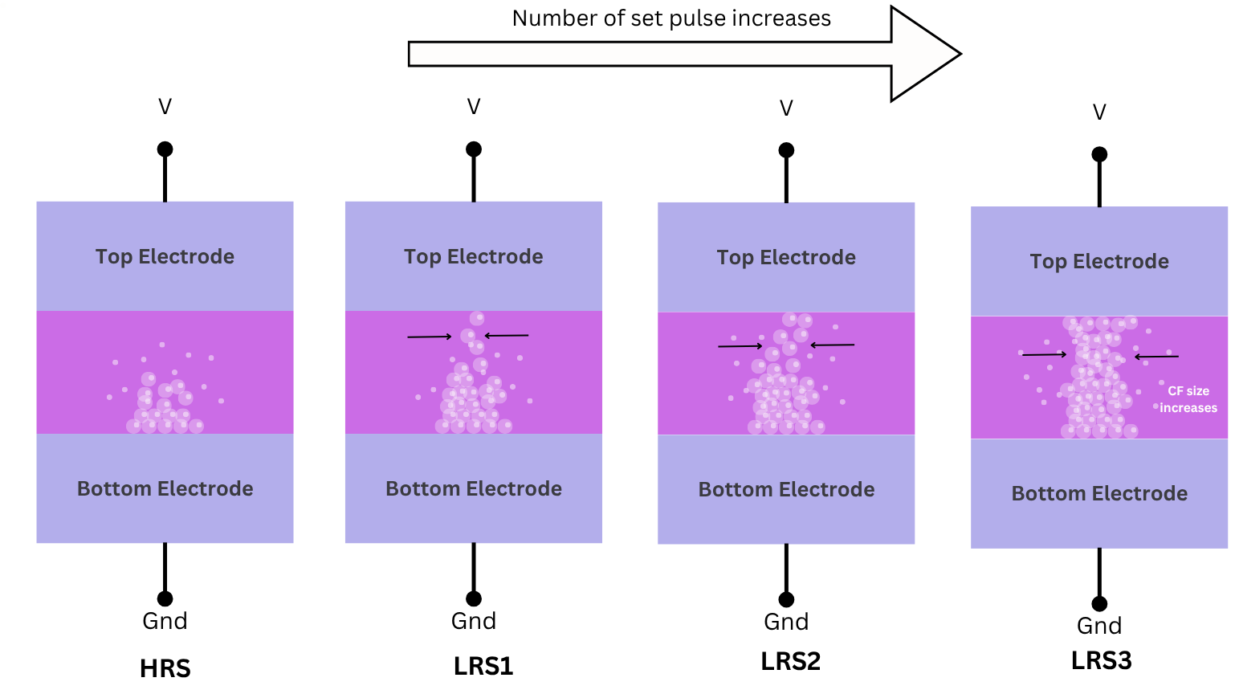
(a)
(b)
Fig 2.2.2: (a) Schematic illustration of multiple Low resistance states in RRAM cell (b) Schematic illustration of multiple High resistance states in RRAM cell.
These synaptic features of RRAM not only emulate biological synapses by also make RRAM to be suitable for in-memory computing, where memory and computing unit are on the same physical unit. RRAM crossbar arrays enable matrix-vector multiplication (MVM) that is performed within memory-array itself, thereby eliminating the need for frequent data movement. This inherent capability of RRAM to both store and process information makes it an ideal candidate for energy-efficient neuromorphic and in-memory computing platforms.

2.3 RRAM-Based Crossbar Arrays for AI Applications
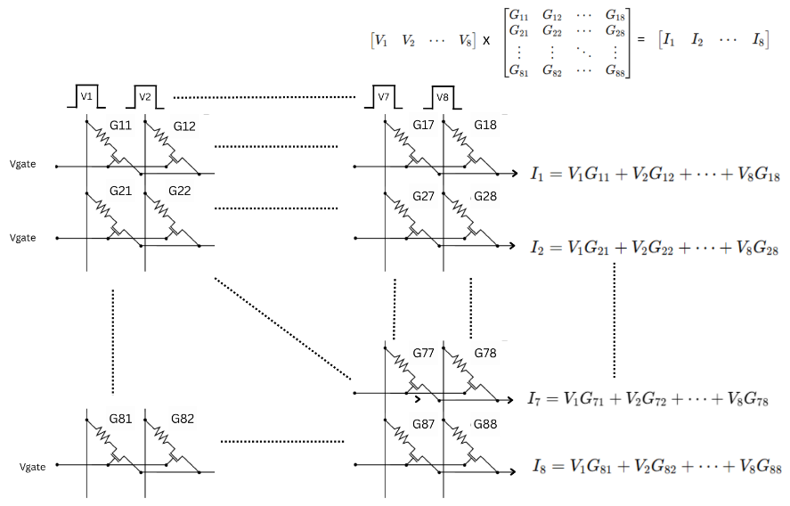
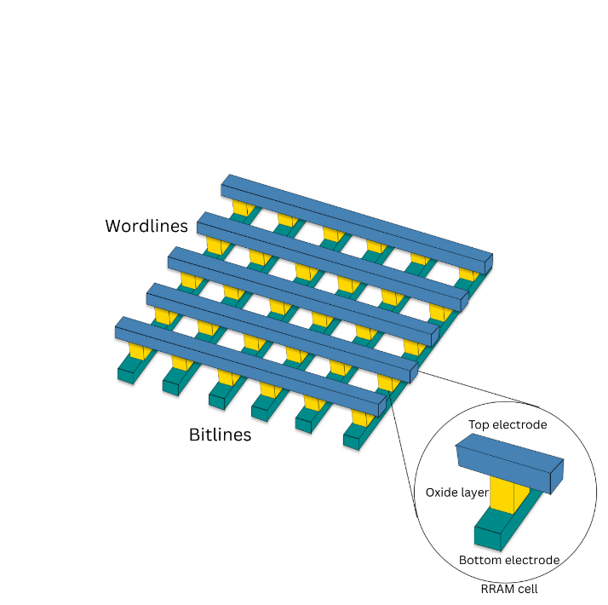
Crossbars are capable of performing matrix-vector multiplication (MAC) operation inside of the memory array. The architecture of RRAM-Crossbar Fig: 2.3.1 includes Orthogonal word lines and bit lines intersect at RRAM cells. Where the input vectors encoded as the input vector, the conductance state as the weights of matrix and the current collected at each Bit line represents the MAC output [6].
Fig 2.3.2: MVM operation in crossbar
Fig 2.3.1: RRAM Crossbar Crossbar

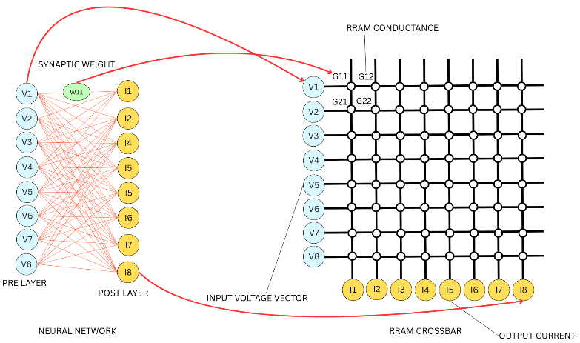
The MAC operation in crossbar is done in the basis of Ohm’s law and Kirchoff’s law Fig 2.3.2. When we ally input voltages at the word line and bit line is grounded due to ohms law currents are produced by multiplication of conductivity of each RRAM cell and the input voltages and these currents got summed up according KCL in each bit line which gave the MAC output. This Mac operation is the basic of the MVM which is building block of a neural network where each RRAM device represents a perceptron in a neural network Fig 2.3.3.
Fig 2.3.3: Comparison between Crossbar and neural network
Read and write operations in RRAM crossbar arrays are critical for utilizing their computational and storage capabilities. The write operation involves applying a sufficient voltage difference across the RRAM cell to induce a change in its resistance state — typically between a high-resistance state (HRS) and a low-resistance state (LRS). This change is governed by the formation and rupture of conductive filaments within the oxide layer of the RRAM device [7].
The read operation is generally performed at a lower voltage that does not disturb the state of the device. The current through the selected cell during a read operation reflects its conductance state, and thereby the stored information. Read operations must be carefully designed to avoid unintentional write (or disturb) effects due to voltage stress [8].
A significant challenge in read and write operation in RRAM crossbar arrays is the sneak path current problem. Sneak paths are unintended current paths through unselected cells in the array that interfere with accurate read or write operations. These parasitic currents can mask the real current through the selected cell, making it difficult to determine the correct resistance state [9]. To address sneak path issues, several solutions have been proposed:
- Selector Devices (1T1R / 1D1R):
One approach is to integrate a selector transistor or a diode with each RRAM cell, forming 1T1R or 1D1R structures. These selector devices ensure that only the targeted cell is activated during read/write operations, by blocking current flow in unselected paths[10]. However, this increases area and complexity, compromising density.
- Biasing Schemes (Half and Partial Bias):
Another widely adopted technique is biasing schemes for reducing sneak path currents while maintaining array density. In these schemes, voltages applied to unselected lines are strategically chosen to minimize the potential difference across unselected cells.
The partial bias scheme is one of the most effective methods without requirement of any extra diode or transistor thus more scalable and space efficient. There are two types of Partial biasing scheme which are:
(i) 1/2-Bias Scheme:
In this scheme, a voltage V is applied to the selected wordline while the selected bitline is grounded. All unselected wordlines and bitlines are biased at V/2. As a result, the fully selected cell experiences a full voltage difference of V, the half-selected cells (which share either the wordline or bitline with the selected cell) see a voltage difference of V/2, and the unselected cells (those not sharing either line) experience 0 V across them. This configuration greatly reduces the unwanted sneak path currents. Since sneak paths primarily emerge through half-selected or unselected cells, the reduced potential across those paths limits the leakage current. Additionally, this mitigates unnecessary stress on the unselected memory cells, enhancing reliability and endurance of the crossbar array[10][11].
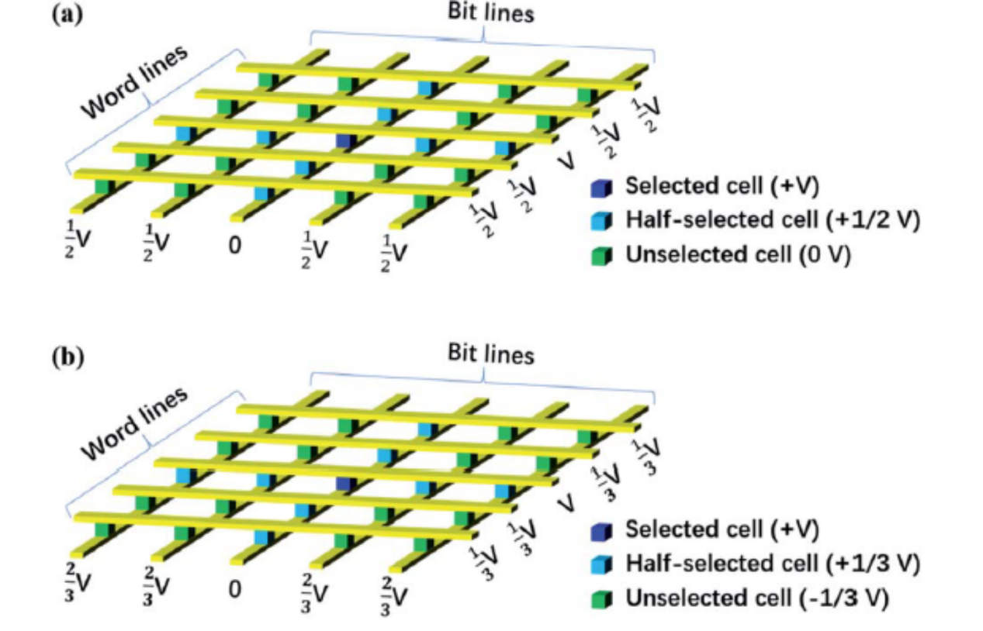
(ii) 1/3-Bias Scheme:
In the 1/3-bias scheme, the voltages are distributed more finely: the selected wordline is biased at V, and the selected bitline is grounded. Meanwhile, the unselected wordlines are biased at V/3and the unselected bitlines at 2V/3. This results in the fully selected cell receiving a full V, the half-selected cells encountering V/3 across their terminals, and unselected cells only experiencing 2V/3−V/3=V/ at most. By further decreasing the voltage exposure across unselected and half-selected cells, this scheme minimizes leakage even more effectively than the 1/2-bias scheme. As a result, sneak path currents are significantly suppressed, leading to enhanced read/write accuracy and reduced power dissipation. However, the implementation requires more sophisticated peripheral circuits to generate and control multiple reference voltages. [12].

Fig 2.3.4: (a) schematic of 1/2 bias scheme. (b) schematic of 1/3 bias scheme.

A study reviewing methods to suppress sneak-path currents in memristor crossbars concludes that both 1/2-bias and 1/3-bias significantly reduce leakage currents, improving array reliability and lowering power consumption. Chen et al. describe that in V/2 bias, half-selected cells drive only half the maximum voltage, resulting in ~50% reduction in sneak current; under V/3 bias, currents drop to around 33% of full-scale values. These results corroborate the idealized example above and demonstrate how partial-bias schemes serve as effective, scalable methods to reduce sneak-path interference in practical RRAM crossbar arrays [13].

2.4 AI Accelerator Architectures Using RRAM
Deep Neural Networks (DNNs) have achieved remarkable performance across a wide range of tasks, but their increasing computational complexity and growing model sizes demand substantial energy and memory bandwidth. Traditional processors like CPUs and GPUs, while versatile, suffer from inefficiencies due to the von Neumann bottleneck, as they rely on separate memory and compute units. This has led to the rise of dedicated AI accelerators such as Google's Tensor Processing Unit (TPU) and NVIDIA's Deep Learning Accelerator (DLA), which are optimized for massive parallelism and high throughput. However, these still involve considerable energy consumption and latency due to memory access overhead.
To address this, RRAM-based crossbar arrays have emerged as promising candidates for in-memory computing, enabling in-situ matrix-vector multiplication (MVM) — the fundamental operation in most neural network computations. Architectures like ISAAC [14], PRIME [15[, and Newton have incorporated RRAM crossbars to reduce data movement between memory and compute units, significantly improving energy efficiency and area usage.
However, many of these architectures face practical interfacing challenges:
- Peripheral circuits such as Digital-to-Analog Converters (DACs), Analog-to-Digital Converters (ADCs), write drivers, and sense amplifiers dominate both area and power consumption, offsetting the gains from in-memory computing.
- DAC/ADC precision and speed trade-offs limit performance at scale.
- Interfacing crossbars with external digital control logic often requires complex voltage biasing schemes for write and read operations, adding to the circuit complexity.
- Managing sneak path currents in large arrays and ensuring accurate analog MVM operation further complicate the hardware design.

CHAPTER 3
Proposed System Architecture

3.1 Overall System Design
The proposed system is designed to demonstrate the memory operations of an 8×8 RRAM crossbar array interfaced through a dedicated analog front-end and controlled via a digital backend implemented on an FPGA. The main objective of this design is to program and read the resistive states of the memory cells effectively through peripheral circuits while maintaining flexibility and precision.
- The overall architecture includes:
- An 8×8 Non-Volatile Memory (NVM) crossbar
- An analog front-end PCB for precise voltage control
- Read circuitry to sense the output
- A digital backend using an FPGA to manage control signals
- Interface with a computer via USB Blaster and JTAG for communication and programming
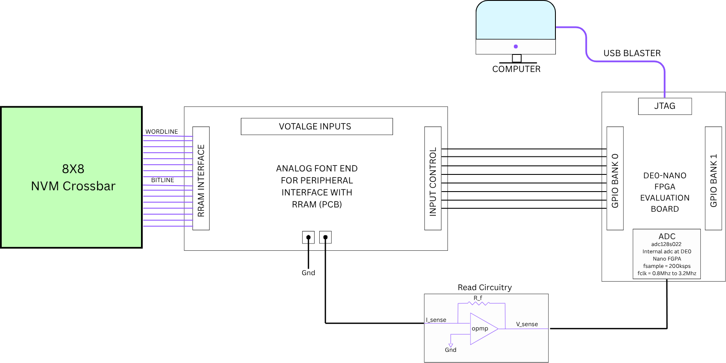
Fig3.1.1: system diagram

Fig. 3.1 illustrates the overall system architecture that integrates all the components. Where first the computer programs the DE0-Nano FPGA that is use to give control signal to the PCB which adjust the voltages according to the required voltage in partial bias scheme across the 8X8 crossbar for read and write task, the Voltage Inputs section in the PCB is for the supply voltage and the Half and Full selected voltages for read and write schemes. The Read circuitry is use to convert the Bit line current to voltage and hold until the digital conversion is completed during the read process. The ADC is inbuilt in the FPGA that is use to read the cell’s conductance.

3.2 Analog Front-End
The analog front-end is responsible for supplying voltage inputs to the crossbar array and capturing the output signals for further processing. It consists of analog multiplexers, analog switches, and decoders to selectively access rows and columns.
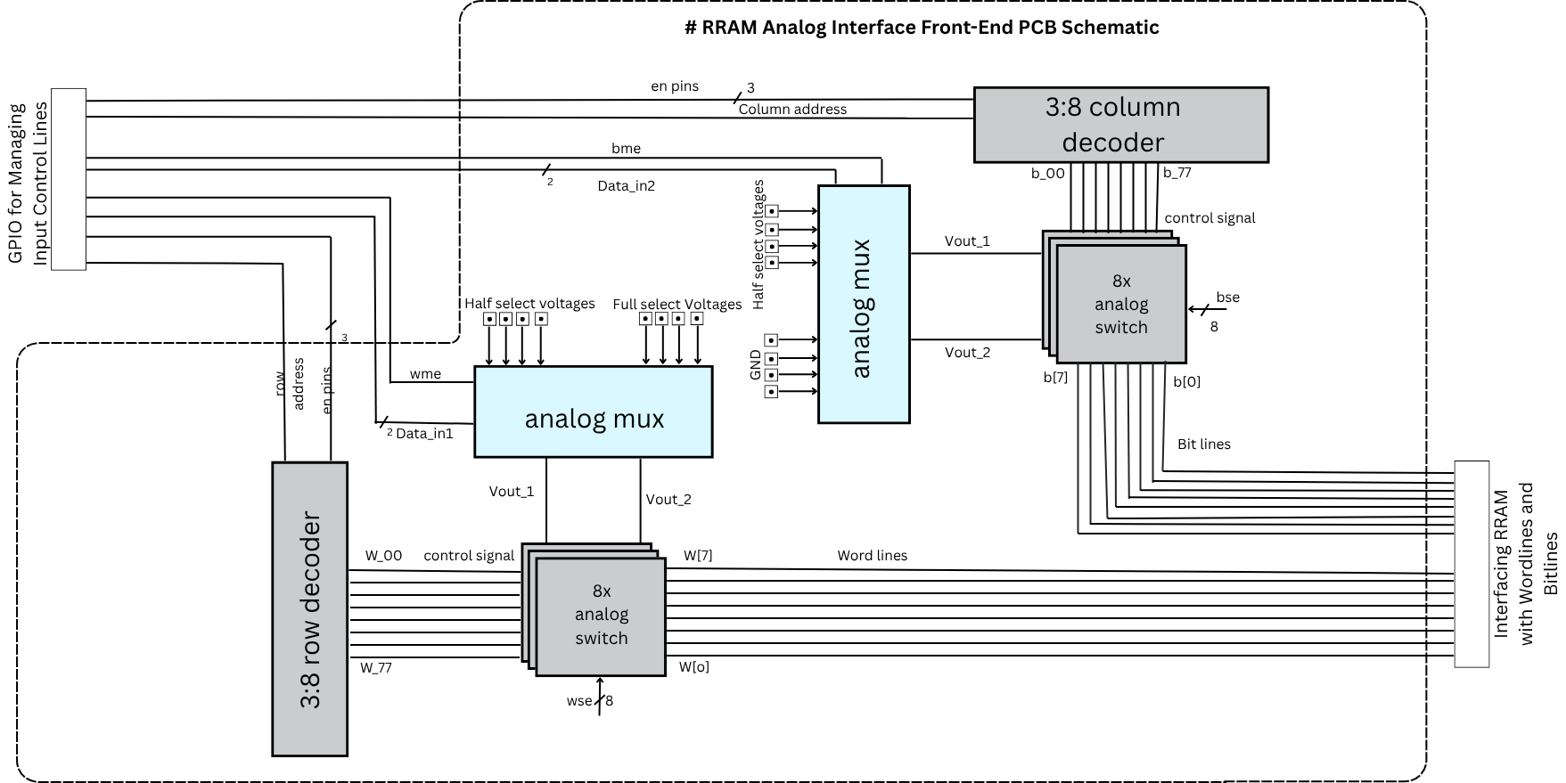
Fig 3.2.1: Block diagram schematic
The Ananlog Multiplexer (adg1609 used in the project) was used to select the voltage levels for different operations. It chooses the voltage from the half-selected voltage, Full selected voltage and Gnd. In these experiment Four mode of operations were used which are Read Operation ( $V_{fullselect}=1 V , V_{halfselect}=0.5 V$ ) , Write Operation ( $V_{fullselect}=2 V , V_{halfselect}=1 V$ ) , Rewrite Operation ( $V_{fullselect}=-2 V , V_{halfselect}=-1 V$ ) , and Ground state ( both voltages are gnd). In the Fig 3.2.1 $V_{fullselect}$ and $V_{halfselect}$ are Vout_1 and Vout_2 respectively. Similarly, The Analog switches (adg1419) are used to demux the Vout_1 and Vout_2 into the wordlines and bitlines. And the controlling of the switch is done by 3:8 decoder which take input address and decode it to map the correct voltage scheme. All the switch and Multiplexers are bidirectional so in the GND input of analog mux corresponding ti the read operation a Transimpedance amplifier is connected and that is further connected to ADC for reading the conductance value.

3.3 Digital Backend using FPGA
DE0 Nano FPGA was used as an evaluation board for the RRAM controller in this project.

Fig 3.3.1: (a) DE0-Nano FPGA Development Board (b) Block diagram of DE0-Nano.
The De0 nano board contains 32 MB SDRAM, 64 MB EPCS64, 2Kbit I2C EEPROM, 2 Dip switches, G-sensor, 80-pin GPIO Header pins on front and 2x13 Pin Header pin at back, 2 Buttons, x8 LED and a 50 MHZ internal crystal oscillator and an On-board SPI based Analog to digital converter with a sampling rate of 200KSPS. A Verilog based RRAM controller was developed in this FPGA to control and interface the RRAM and read its cell value using the in-built ADC.
3.4 Control Logic Implementation
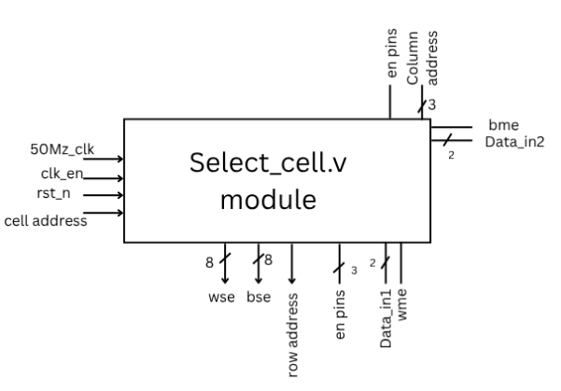
A control logic was implemented using Verilog named select_cell and ADC_ctrl and a Top module of RRAM_Controller. The select_cell Fig: 3.4.1 was the Central controlling unit of the RRAM controller that was use to send signals like address, read, write signals to the PCB and to generate a voltage pulse and also a “done” or “finish” signal indicating that the voltage pulse is generated and now the ADC can sample the bit line current if it’s a read operation. The select_cell is implemented and tested in two algorithms: (1) FSM based control, (2) Counter based control with continuous assessment.
Fig 3.4.1: Select_cell block diagram
The pins in the Select_cell.v module (Fig: 3.4.1) are used for controlling address decoding, data selection, and read/write operations. Address decoding is managed using row_add, column_add, wse, and bse, which activate the required wordline and bitline switches. Active-low signals we1_n, we2_n, be1_n, and be2_n control the write enable logic. Read/write direction and MUX channel selection are controlled via wl_rdrw, bl_rdrw, datain_1, datain_2, wme, and bme. Clocking, reset, and data inputs are managed using clk, clk_en, rst_n, W, B, Data_input, and counts.
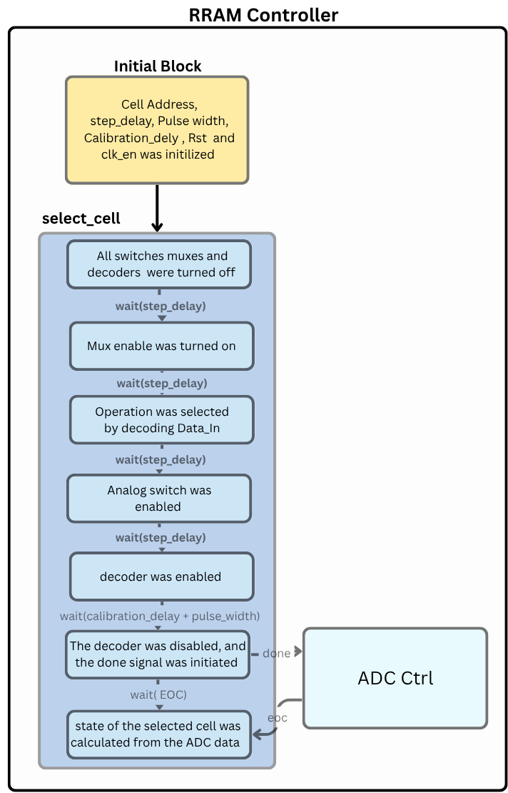
FSM Based Control Logic:
The select cell was implemented with Finite State Machine (FSM) Fig: 3.4.2 with 7 states (S0 to S1) encoded in binary form. The inputs were initialized using an Initial block in the top RRAM Controller module. Step delay is the delay between every state for bypassing the settling time of the ICs. The calibration_delay is calculated by simulating different values and it is used to settle all the logics inside the FPGA and PCB. And Pusle Width is the pulse width of the voltage pulse. The detail State diagram of the FSM is shown in the Fig 3.4.2. Done signal is used as Start of conversion for the ADC and then it waits until it receives the EOC (end of conversion) signal and then performs the rest task.
Counter Based Continuous assessment Logic:
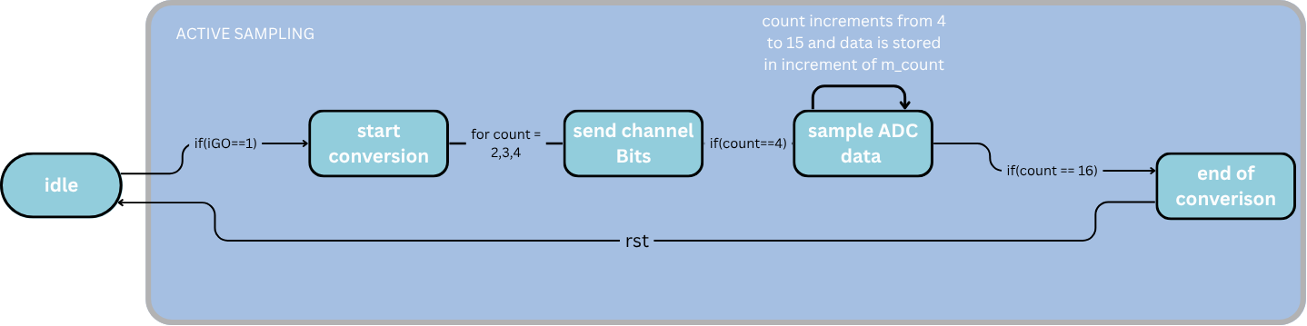
The select cell was implemented with three always block. The first always block was used as a counter for every positive clock while finished signal is not Logic ‘1’. The Second always block was implemented with if statement.when the counter was 20 all the enables except decoder was turned on, when the counter was 40 values were assigned to the internal resisters, when it was 60 decoder was enabled and when it was 60 + calibratiuon_delay + pulse_width decoder was turned off. The third always block is used to continuously assign assign the internal resisters to the Output ports with every negative clock edge.
Fig 3.4.3: ADC_CTRL Flowchart
Fig 3.4.2: FSM Based control Flowchart

The ADC_CTRL is used to control the internal ADC in the FPGA to decode the Bit line current. It uses a SPI Dual Cloak communication protocol for communicating the ADC. The working flowchart of the module is shown in Fig: 3.4.3.

CHAPTER 4
Simulation and Experimental Setup

4.1 Simulation Environment
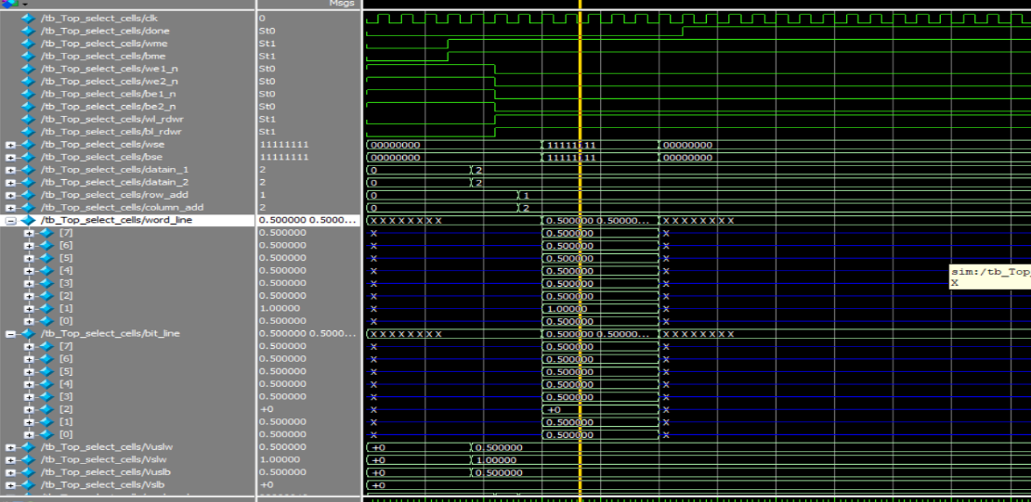
The control logic was implemented in Verilog. Modelsim was use to simulate and verify the control algorithm. To simulate the analog behaviour of the analog-front end Fig: 3.2.1, a test-bench using system-Verilog was built. All the transition delay, propagation delay of the ICs were calculated using LT Spice simulation of each and every ICs and the delays were then modelled into the test bench emulation of the PCB. Then while simulating the Control logic for generating a read pulse of 500ns, a pulse width of 487ns was observed.
Fig 4.1.1: Simulation result
As observed in the simulation timing diagram Fig: 4.1.1 the partial bias scheme of Full select voltage 1V and half select voltage 0.5 V was only for nearly 500 ns.
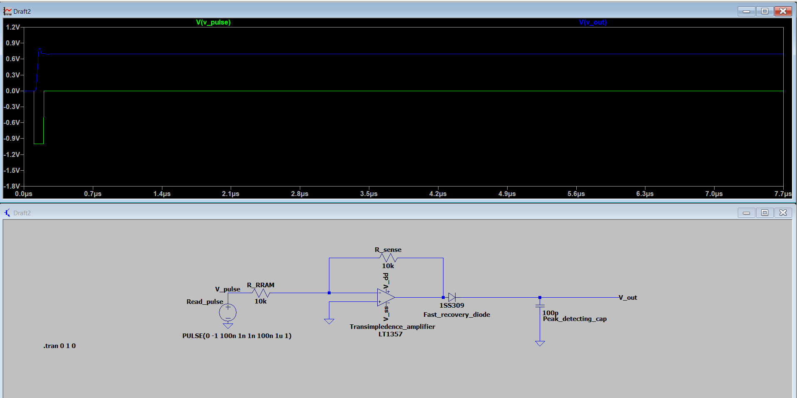
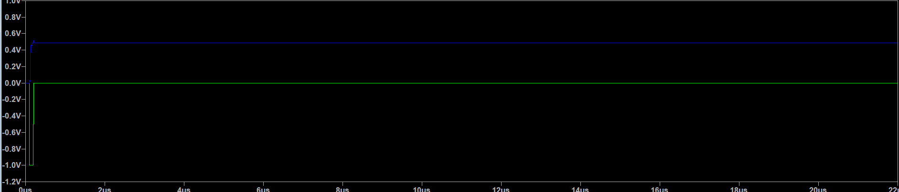
- (b)
Fig 4.1.2: (a) New read circuitry (b) LT Spice simulation
As the ADC was of 200 KSPS that is very slow to detect 500 ns pulse so the read circuitry was updated to a peak detect and hold circuit Fig: 4.1.2 (a) and a switch is to be connected to across the hold capacitor later for discharging it and it is a MOSFET based switch that is connected to FPGA for better control. As per the simulation Fig: 4.1.2 (b) it can be observed that for 1 V of 5 ns it can hold a peak of 0.4 V for atleast 8 us steady which is enough for the ADC to sample.
4.2 Experimental Setup
The experiment was carried out to verify the Working of select_cell module. The Apparatus that was used to carry out the experiment were:
- De0-Nano (Cyclone IV) FGPA Evaluation Board
- Tektronix TPP0250 probes (250 MHz Bandwidth)
- Keysight Triple Source DC power supply
- Internal FPGA PLL-generated clocks at varying frequencies
- PCB Development Board for interfacing RRAM
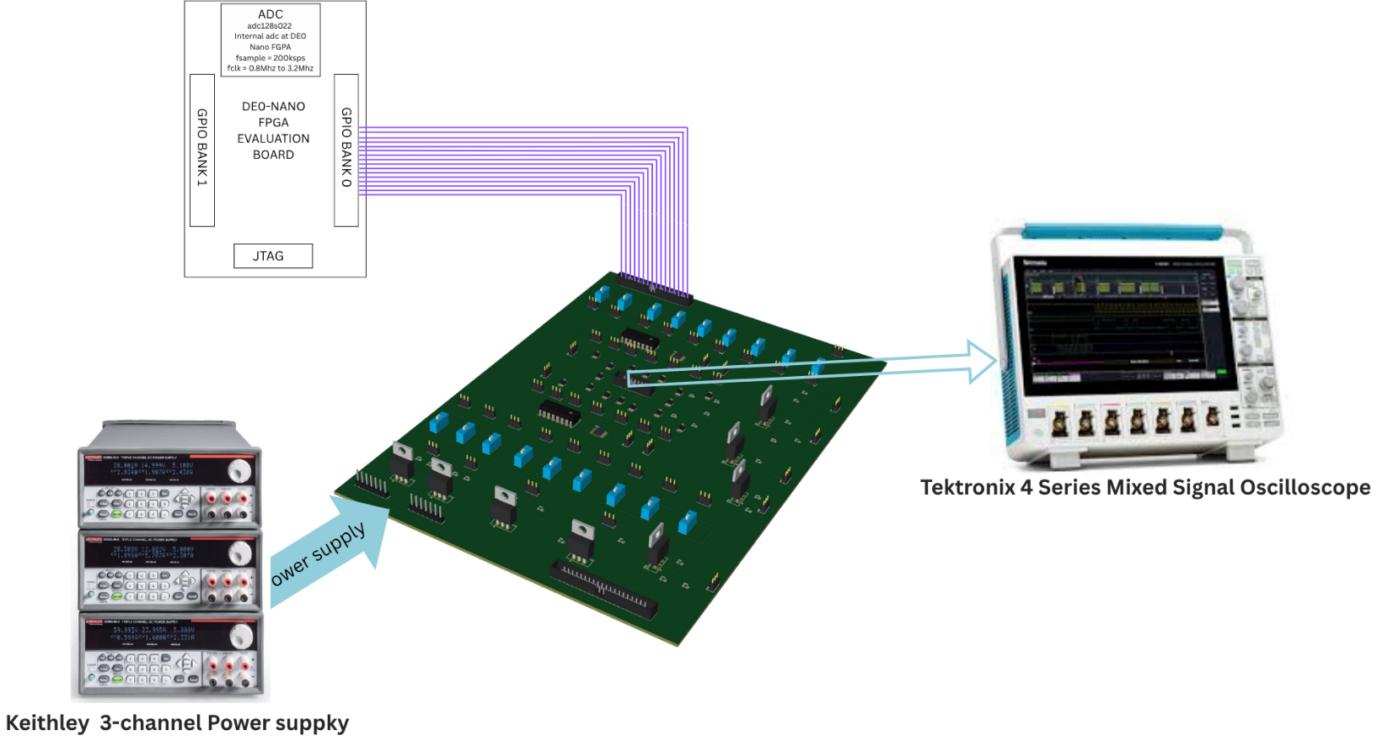
A detailed connection and diagram of experimental setup is given in Fig: 4.2.1.
Fig 4.2.1: Rough sketch for experimental setup
The programming tool that was use was Intel Quartus Prime 20.1.1 for both synthesis and programming of the device. And the pulse wave form was observed at the oscilloscope for different frequencies of clock and pulse widths for analysing the performance of the device and to find potential flaws and frequency range.

Procedure of the experiment was:
- A Verilog module to produce read/write pulses was synthesized in the De0 Nano using Quartus Prime and interfaced with a PCB.
- The pulse width was adjusted accordingly: 500ns, 5 μs, 50 μs, 500 μs, and 1 ms, respectively.
- The output waveforms were captured on the oscilloscope for analysis.
- Additional tests were done by modifying slew rate and output drive strength in Quartus: Slew rate was kept at 2 and the current strength reduced from 8 mA to 4 mA

4.3 Results and Observations
After synthesis the maximum setup and hold lag was found to be 19.37 ns, as it was positive so the timing requirements were meet properly. And then the proper connection was made and the FPGA was programmed and the results were captured in oscilloscope for different pulse width.
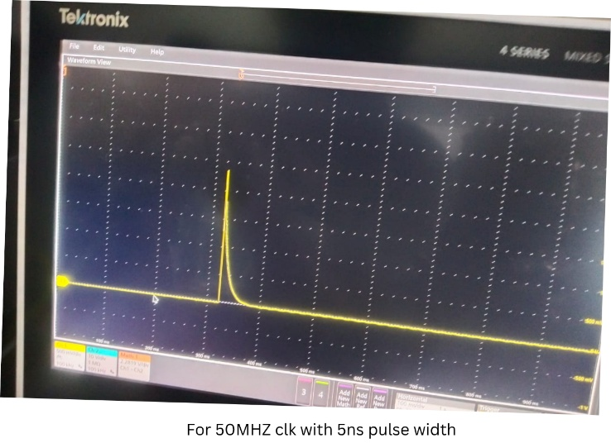
Fig: 4.3.1 Result obtained for 5 ns pulse width

When the code was tested for 50 Mhz clock and 5 ns pulse width it was observed a sharp peak with hyperbolic decrease of a voltage peak of 2 V instead of a square pulse of 2 V.
Fig 4.3.2: Results for 5us to 1ms range.
At a frequency of 1 MHz with a 5 µs pulse width, the waveform shows a peak voltage of approximately 2.2 V, but with a noticeable ringing and overshoot following the rising edge. The signal does not settle cleanly and exhibits an underdamped response, likely due to impedance mismatch and parasitic inductance. The average voltage measured over the pulse duration is around 1.75 V, indicating signal instability and energy oscillation within the system. At 100 kHz with a 50 µs pulse width, the output waveform still reaches a peak of 2.2 V, but the average voltage over the entire pulse duration drops to 1.44 V, with the final part of the pulse (24 µs to 50 µs) averaging around 1.78 V. This suggests a slower settling time, along with overshoot during the rising edge. The waveform shows signs of a capacitive charging curve, hinting at the influence of parasitic capacitance at this mid-frequency range. At 10 kHz with a 500 µs pulse width, the waveform appears significantly cleaner, with sharp rising and falling edges, and a consistent peak and average voltage of 2.2 V. There is minimal overshoot or distortion, indicating that the signal has sufficient time to settle, and parasitic effects are much less pronounced at this frequency. At 5 kHz with a 1 ms pulse width, the waveform is the most ideal of all cases, showing smooth transitions, clean square edges, and an average peak voltage of approximately 2.22 V. No visible overshoot or ringing is observed, and the waveform maintains high integrity throughout.

CHAPTER 5
Conclusion and Future Scope

6.1 Summary of Contributions
This work presented the design, simulation, and implementation of a prototype RRAM controller, including analog voltage bias circuitry and digital control logic. An 8×8 crossbar was successfully interfaced using partial bias schemes to emulate synaptic behaviour. Both the analog and digital sub-systems were verified through simulation and physical experiments. This design demonstrates the feasibility of creating modular memory controllers for future in-memory and neuromorphic applications.
6.2 Key Results
We successfully built and tested an RRAM controller, functionally similar to an SDRAM controller, tailored for neuromorphic memory access. The analog front-end showed clean voltage waveforms at low frequencies (5–10 kHz), and the digital backend effectively managed timing-sensitive operations. The read circuitry was redesigned for low-speed ADC compatibility, showing a peak voltage retention of over 8 μs. All control logic was FSM-driven, ensuring deterministic sequencing of memory operations.
6.3 Limitations and Challenges
At higher frequencies, output signal transitions become significantly faster. This introduces several signal integrity issues like Ringing and overshoot, Reflections And noise sensitivity. In contrast, at lower frequencies waveforms appear cleaner with minimal reflections and less susceptibility to high frequency noises. The ringing and overshoots were observed when the voltage levels are switching these leads to the conclusion that it is due to the switching frequency requirements of the ICs were not met. So, ICs of High switching frequency of atleast 1 GHZ should be used.

6.4 Future Work
In the next phase, this setup will be expanded to perform MAC (Multiply-Accumulate) operations directly within the crossbar, forming the computational core of an AI accelerator. Our goal is to develop a novel AI accelerator architecture leveraging RRAM crossbars, enabling energy-efficient deep learning hardware. Further extensions will include multibit conductance tuning, support for online learning (e.g., STDP), and integration with spiking neural networks for edge AI applications.

REFERENCES
- Zahoor, F., Zulkifli, T. Z. A., & Khanday, F. A. (2020). Resistive random access memory (RRAM): An overview of materials, switching mechanisms, performance, multilevel cell, modelling, and applications. Nanoscale Research Letters, 15, 90. https://doi.org/10.1186/s11671-020-03372-7
- Pan, F., Gao, S., Chen, C., Song, C., & Zeng, F. (2014). Recent progress in resistive random access memories: Materials, switching mechanisms, performance, and applications. Materials Science and Engineering: R: Reports, 83, 1–59. https://doi.org/10.1016/j.mser.2014.06.002
- Chang, T., Jo, S. H., & Lu, W. (2011). Short-term memory to long-term memory transition in a nanoscale memristor. ACS Nano, 5(9), 7669–7676. https://doi.org/10.1021/nn202954t
- Hu, Q., Wang, Y., Wu, H., Yu, S., & Wong, H.-S. P. (2018). Experimental demonstration of analog synaptic learning with RRAM devices. IEEE Journal on Emerging and Selected Topics in Circuits and Systems, 8(1), 137–146. https://doi.org/10.1109/JETCAS.2018.2808259
- Paul, S., & Sanyal, A. (2020). A review on neuromorphic and in-memory computing hardware: Challenges and opportunities. IEEE Access, 8, 222994–223021. https://doi.org/10.1109/ACCESS.2020.3043456
- Sebastian, A., Le Gallo, M., Khaddam-Aljameh, R., & Eleftheriou, E. (2020). Memory devices and applications for in-memory computing. Nature Nanotechnology, 15, 529–544. https://doi.org/10.1038/s41565-020-0655-z
- Waser, R., & Aono, M. (2007). Nanoionics-based resistive switching memories. Nature Materials, 6(11), 833–840. https://doi.org/10.1038/nmat2023
- Chang, T., Jo, S. H., & Lu, W. (2013). Synaptic behaviors and modeling of a metal oxide RRAM device for neuromorphic applications. Nanotechnology, 24(38), 384002. https://doi.org/10.1088/0957-4484/24/38/384002
- Borghetti, J., Snider, G. S., Kuekes, P. J., Yang, J. J., Stewart, D. R., & Williams, R. S. (2010). ‘Memristive’ switches enable ‘stateful’ logic operations via material implication. Nature, 464(7290), 873–876. https://doi.org/10.1038/nature08940
- Xia, Q., Yang, J. J., Li, X., Huang, X., & Lu, W. D. (2009). Memristor–CMOS hybrid integrated circuits for reconfigurable logic. Nano Letters, 9(10), 3640–3645. https://doi.org/10.1021/nl901874j
- Zidan, M. A., Strachan, J. P., & Lu, W. D. (2013). The future of electronics based on memristive systems. Nature Electronics, 1(1), 22–29. https://doi.org/10.1038/s41928-017-0006-8
- Guo, T., Li, D., Wang, J., & Wang, Z. (2011). Suppression of sneak-path current in memristor crossbar arrays. IEEE Transactions on Nanotechnology, 10(6), 1376–1383. https://doi.org/10.1109/TNANO.2011.2160024
- Chen, A., Yu, S., & Wong, H. S. P. (2015). Design considerations of RRAM crossbar array for suppressing sneak-path current. IEEE Transactions on Electron Devices, 62(11), 4022–4028. https://doi.org/10.1109/TED.2015.2478706
- Shafiee, A., Nag, A., Muralimanohar, N., Balasubramonian, R., Strachan, J., Hu, M., ... & Wang, X. (2016). ISAAC: A convolutional neural network accelerator with in-situ analog arithmetic in crossbars. In 2016 ACM/IEEE 43rd Annual International Symposium on Computer Architecture (ISCA) (pp. 14–26). https://doi.org/10.1109/ISCA.2016.12
- Chi, P., Li, S., Xu, C., Zhang, T., Zhao, J., Liu, Y., & Xie, Y. (2016). PRIME: A novel processing-in-memory architecture for neural network computation in ReRAM-based main memory. In 2016 ACM/IEEE 43rd Annual International Symposium on Computer Architecture (ISCA) (pp. 27–39).
- Zou, X., Xu, S., Chen, X., Yan, L., & Han, Y. (2021). Breaking the von Neumann bottleneck: architecture-level processing-in-memory technology. Science China Information Sciences, 64, Article 160404.
- Indiveri, G., & Liu, S.-C. (2015). Memory and information processing in neuromorphic systems. Proceedings of the IEEE, 103(8), 1379–1397.
- Indiveri, G., Linares-Barranco, B., Legenstein, R., Deligeorgis, G., & Prodromakis, T. (2013). Integration of nanoscale memristor synapses in neuromorphic computing architectures. Frontiers in Neuroscience.
- Bi, G.-Q., & Poo, M.-M. (1998). Synaptic modifications in cultured hippocampal neurons: Dependence on spike timing, synaptic strength, and postsynaptic cell type. Journal of Neuroscience, 18(24), 10464–10472.
- Mano, M. M., & Kime, C. R. (2007). Logic and Computer Design Fundamentals (4th ed.). Prentice Hall.
- Linear Technology. (2014). LTspice IV Simulator and User Manual. Linear Technology Corporation.

